SOFTWARE REQUIREMENTS SPECIFICATION

**For**

**Airline Reservation System**

# Introduction

## 1.1 Purpose

The main purpose of the Airline Reservation System is to provide a user-friendly platform for customers to efficiently book and manage their airline tickets. The system's objective is to streamline the reservation process, allowing users to easily search for flights, make bookings, select seats, and complete secure transactions. This project describes the hardware and software interface requirements using ER diagrams and UML diagrams.

## 1.2 Document Conventions

* + - Entire document should be justified.
    - Convention for Main title

Font face: Times New Roman Font style: Bold

Font Size: 14

* + - Convention for Sub title

Font face: Times New Roman Font style: Bold

Font Size: 12

* + - Convention for body

Font face: Times New Roman Font Size: 12

## 1.3 Scope of Development Project

This is basically an interface of Global distribution System to carry out reservations on the desired

airline from any place. Airline Reservation System make the life of passengers very easy as they don’t need to stand in queue for getting their seats reserved and they can easily make reservations on any airline just from a single system. On the other hand, it also removed an extra burden from the Airline Department as most of the passengers and travel agencies use this service instead of making reservations from the counters. With the help of this system, customers can view all the different flight’s availability with different timings for a particular date and it also allows them to

reserve a seat, cancel a reservation or modify it. The only problem with the system is that it doesn’t allow the passengers to change the particular part of his or her reservation. Apart from the fight details, it also displays information that how many passengers are going to board a particular flight. The users follow the same steps no matter what is their mode of system access is, namely, phone, interne or the information desk at any part of the world, keeping consistency in the system.

## 1.4 Definitions, Acronyms and Abbreviations

JAVA -> platform independence SQL-> Structured query Language ER-> Entity Relationship

UML -> Unified Modeling Language

IDE-> Integrated Development Environment SRS-> Software Requirement Specification

## 1.5 References

* + - Books

 Software Requirements and Specifications: A Lexicon of Practice, Principles and Prejudices (ACM Press) by Michael Jackson

Software Requirements (Microsoft) Second Edition By Karl E. Wiegers

Software Engineering: A Practitioner’s Approach Fifth Edition By Roger S. Pressman

* + - Websites

**<https://www.flightslogic.com/>**

**<https://www.technoheaven.net/flight-module.aspx/>**

# Overall Descriptions

## 2.1 Product Perspective

Use Case Diagram of Library Management System

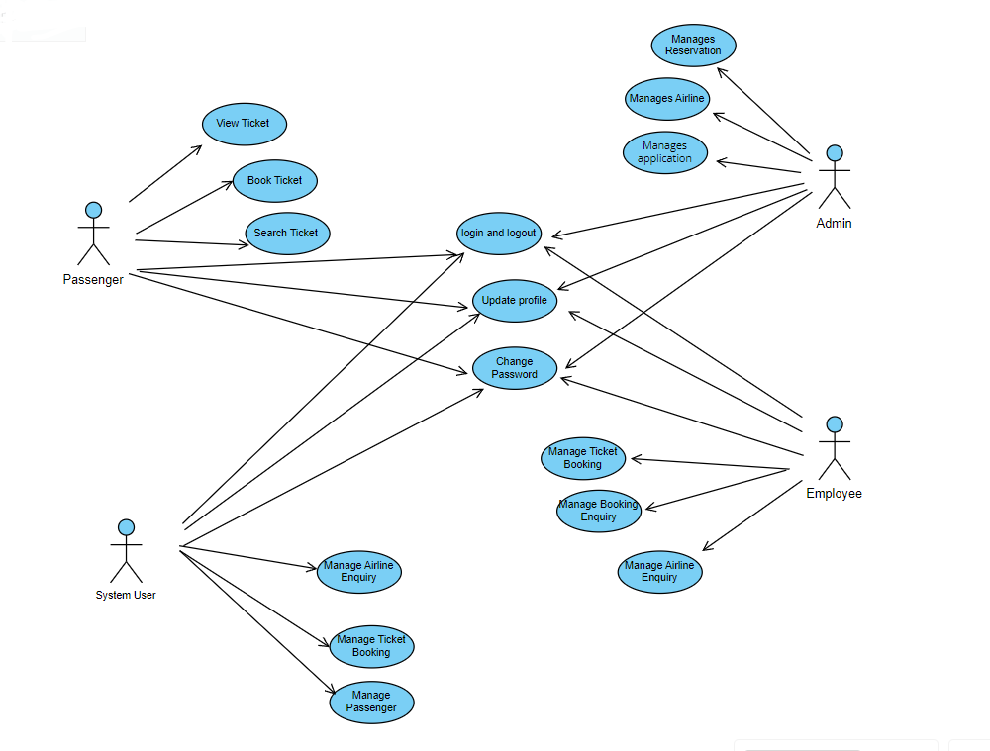

1

## 2.2 Product Function

Entity Relationship Diagram of Library Management System

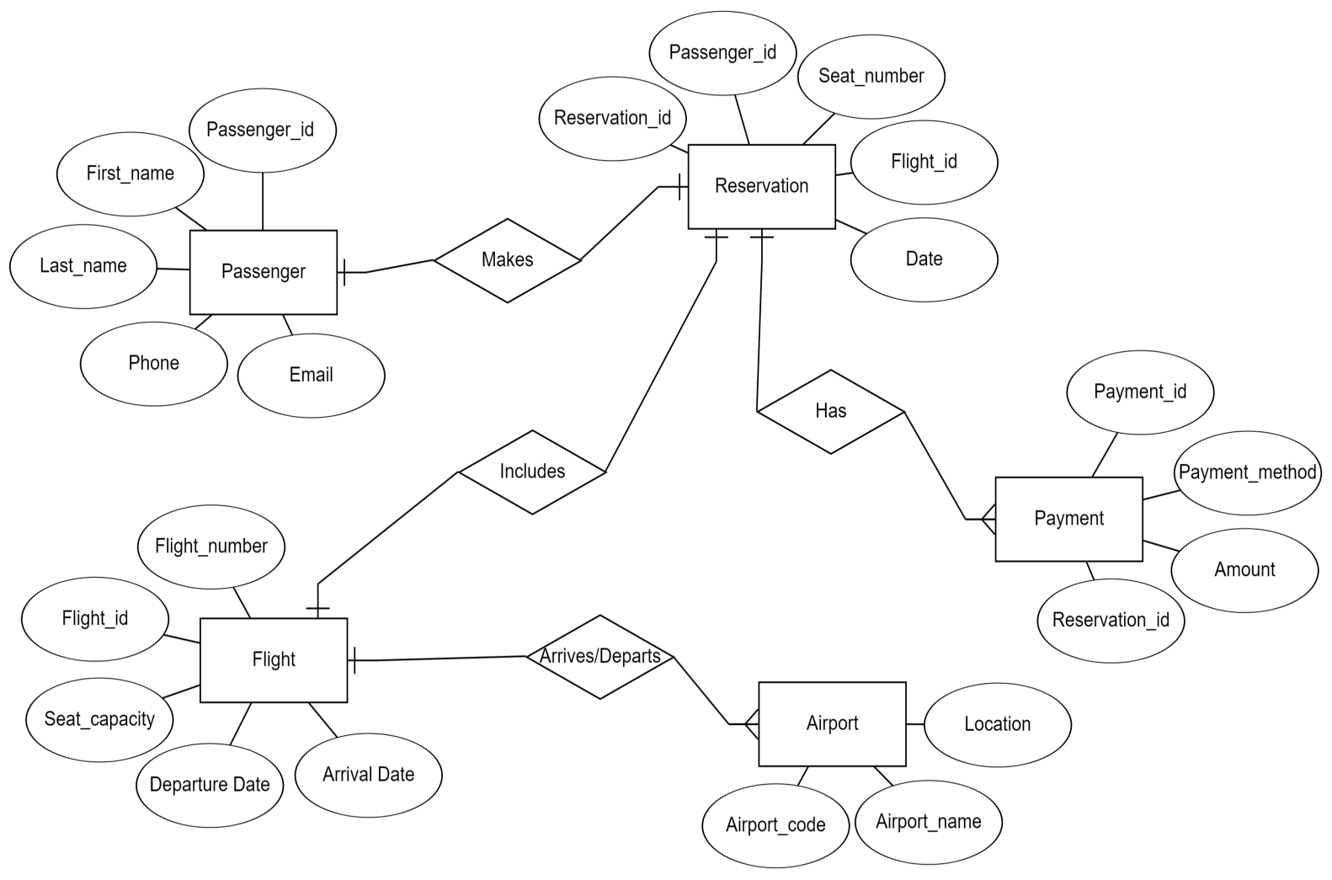

An airline reservation system is a computerized platform that allows users to book flights, manage

reservations, and check flight details. It typically involves databases of flight schedules, seat

availability, and customer information, enabling airlines to efficiently handle bookings, cancellations,

and other aspects of passenger travel.

## 2.3 User Classes and Characteristics

An airline reservation system is a computerized platform that allows users to book flights, manage reservations, and check flight details. It typically involves databases of flight schedules, seat availability, and customer information, enabling airlines to efficiently handle bookings, cancellations, and other aspects of passenger travel.

The features that are available to the Passenger are:-

* + - Provide options to manage personal information and preferences.
    - Allow users to view and choose their seats during the booking process. Can view the List of books available in each category.
    - Display seat maps with available seats and amenities .
    - Integrate secure payment gateways for online transactions.
    - Support various payment methods, such as credit cards and digital wallets .
    - Send immediate confirmation emails or SMS messages upon successful booking.
    - Use feedback to improve services and features
    - Clearly communicate privacy policies.

The features that are available to the Admin are:-

* + - Implement a secure login system for administrators.
    - Allow admins to update their profiles, including contact information.
    - Provide a dashboard with an overview of system performance, booking statistics, and key metrics.
    - View and manage all flight reservations.
    - Modify or cancel reservations as needed.
    - Resolve booking conflicts and address overbooking scenarios.
    - View and manage payment transactions.
    - Customize email templates and notifications
    - Implement security measures to safeguard sensitive information.
    - Provide a secure logout option for administrators to end their sessions.

The features that are available to the employee are:-

* + - Define employee roles with appropriate access levels based on job responsibilities.
    - Allow employees to update their profiles, including contact information.
    - Enable employees to view and update flight schedules.
    - Allow employees to manage seat allocation and configuration for flights.
    - Assist passengers with the check-in process.
    - Enable employees to access real-time flight status information
    - Implement features for employees to manage their work schedules.
    - Provide a secure logout option for employees to end their sessions.

## 2.4 Operating Environment

## The airline reservation system's operating environment includes compatibility with major browsers such as Microsoft Internet Explorer, Google Chrome, and Mozilla Firefox. It should ideally support Internet Explorer 6.0 and be compatible with Mozilla Firefox and Opera 7.0 or higher versions. The system requires an internet connection for access. In terms of hardware, a basic configuration may include a 40 GB hard disk, a 15" color monitor, and standard input/output devices like a keyboard, mouse, and printer.

## 2.5 Assumptions and Dependencies

The assumptions are:-

* + - Assumes that the system's code is free from critical errors to ensure reliable and secure operation.
    - Assumes the system provides a user-friendly interface for ease of use by passengers during flight bookings.
    - Assuming that user information, flight details, and reservations are stored in a database accessible by the reservation system.
    - Assuming the system has sufficient storage capacity and provides fast access to the database to handle a large volume of flight and passenger data.
    - Assuming the system offers a search facility for finding flights efficiently and supports quick and reliable transaction processing.

The dependencies are:-

* + - The proper functioning of the airline reservation system depends on specific hardware and software configurations.
    - The project development and execution are dependent on accurately listing and specifying requirements, ensuring that the system aligns with user needs.
    - The effective operation of the system relies on end users, including administrators, having a proper understanding of the product for efficient management.
    - The system's functionality depends on the availability and accuracy of general reports, providing insights into overall system performance.
    - Information about all users and flight-related data must be stored in a database accessible by the airline reservation system for seamless functionality.

## 2.6 Requirement

Software Configuration:-

This software package is developed using java as front end which is supported by sun micro system. Microsoft SQL Server as the back end to store the database.

Operating System: Windows NT, windows 98, Windows XP Language: Java Runtime Environment, Net beans 7.0.1 (front end) Database: MS SQL Server (back end)

Hardware Configuration:-

Processor: Pentium(R)Dual core CPU

Disk: 40GB

RAM: 256 MB or more

## 2.7 Data Requirement

## The Airline Reservation System necessitates comprehensive data management, including passenger information such as names, contact details, and travel preferences. Flight data, encompassing schedules, availability, and pricing, is crucial for real-time booking and reservation updates. Financial data for secure transactions, payment confirmations, and billing records must be handled securely. Additionally, the system relies on airport data to facilitate check-in, boarding, and baggage handling processes. Regular updates from external sources, such as weather services and regulatory databases, ensure the system remains current and compliant, contributing to a seamless and informed travel experience.

# External Interface Requirement

## 3.1 GUI

The software provides good graphical interface for the user and the administrator can

operate on the system, performing the required task such as create, update, viewing the details

of the book.

Login Interface:-

In case the user is not yet registered, he can enter the details and register to create his account.

Once his account is created he can ‘Login’ which asks the user to type his username and

password. If the user entered either his username or password incorrectly then an error

message appears.

Search:-

The member or librarian can enter the type of book he is looking for and the title he is

interested in,then he can search for the required book by entering the book name.

Categories View:-

Categories view shows the categories of books available and provides ability to the

librarian to add/edit or delete category from the list.

Librarian’s Control Panel:-

This control panel will allow librarian to add/remove users; add, edit, or remove a resource.

And manage lending options.

# System Features

The users of the system should be provided the surety that their account is secure.

This is possible by providing:-

* The system ensures secure login for both passengers and airline staff, employing robust authentication measures.
* It offers a user-friendly interface with comprehensive search and booking functionalities, providing passengers with real-time availability and pricing information.
* Passengers can easily choose their seats through interactive seat maps, enhancing the booking experience.
* The system integrates with secure payment gateways, supporting multiple payment methods for online transactions.

# Other Non-functional Requirements

## 5.1 Performance Requirement

Performance requirements ensure the airline reservation system operates smoothly, with

scalability, reliability, and efficient handling of transactions and data.

* + - Quick responses for flight searches and bookings (within 2 seconds) and authentication and authorization processes completed promptly (within 1 second).
    - Database queries for flights and reservations with an average response time of less than 200 milliseconds.Optimization tasks scheduled during non-peak hours.
    - The system should be able to handle large amount of data. Thus it should accommodate high number of books and users without any fault.
    - System architecture designed for horizontal scaling to accommodate increased user loads. Seamless deployment of additional server instances for increased demand.

## 5.2 Security Requirement

## Security Monitoring implement intrusion detection and prevention systems to monitor and respond to potential security threats. Regularly conduct security audits and vulnerability assessments.

* The system shall comply with relevant data protection and privacy regulations. Passenger data, including personal information and travel history, shall be handled with strict confidentiality.
* Conduct regular security training sessions for system users and administrators. Ensure awareness of security best practices and protocols.
* Implement regular and automated backups of the system's database and critical files.
* Develop and document a comprehensive data recovery plan in the event of a security incident.

## 5.3 Requirement attributes

* There may be multiple admins creating the project, all of them will have the right to create changes to the system. But the members or other users cannot do changes
* The project should be open source
* The Quality of the database is maintained in such a way so that it can be very user friendly to all the users of the database
* The user be able to easily download and install the system

## 5.4 Business Rules

A business rule is anything that captures and implements business policies and practices. A rule can enforce business policy, make a decision, or infer new data from existing data.This includes the rules and regulations that the System users should abide by. This includes the cost of the project and the discount offers provided. The users should avoid illegal rules and protocols. Neither admin nor member should cross the rules and regulations.

## 5.5 User Requirement

The users of the airline reservation system consist of passengers and system administrators

responsible for overseeing and maintaining the system .The administrators of the system

should have more knowledge of the internals of the system and is able to rectify the small

problems that may arise due to disk crashes, power failures and other catastrophes to

maintain the system. The proper user interface, user manual, online help and the guide to

install and maintain the system must be sufficient to educate the users on how to use the

system without any problems. The admin provides certain facilities to the users in the form

of:-

* Backup and Recovery
* Forgot Password
* Data migration i.e. whenever user registers for the first time then the data is stored in the server
* Data replication i.e. if the data is lost in one branch, it is still stored with the server
* Auto Recovery i.e. frequently auto saving the information
* Maintaining files i.e. File Organization
* The server must be maintained regularly and it has to be updated from time to time

# Other Requirements

## 6.1 Data and Category Requirement

The airline reservation system needs to handle user info, flight schedules, available seats, and transactions effectively. Users should see their details and booking history, making it easy to personalize or change reservations. Flight details, like routes and aircraft info, must be clear and constantly updated. A well-organized database is essential for quick and smooth data handling. Also, secure payment integration is crucial for safe transactions. These basics make a solid foundation for a user-friendly airline reservation system, making sure things run smoothly for both passengers and administrators.

## 6.2 Appendix

A: Admin, Abbreviation, Acronym, Assumptions; B: Books, Business rules; C: Class, Client, Conventions; D: Data requirement, Dependencies; G: GUI; K: Key; L: Library, Librarian; M: Member; N: Non-functional Requirement; O: Operating environment; P: Performance,Perspective,Purpose; R: Requirement, Requirement attributes; S: Safety, Scope, Security, System features; U: User, User class and characteristics, User requirement;

## 6.3 Glossary

The following are the list of conventions and acronyms used in this document and the project

as well:

* + - Administrator: A login id representing a user with user administration privileges to the software
    - User: A general login id assigned to most users
    - Client: Intended users for the software
    - SQL: Structured Query Language; used to retrieve information from a database
    - SQL Server: A server used to store data in an organized format
    - Layer: Represents a section of the project
    - User Interface Layer: The section of the assignment referring to what the user interacts with directly
    - Application Logic Layer: The section of the assignment referring to the Web Server. This is where all computations are completed
    - Data Storage Layer: The section of the assignment referring to where all data is recorded
    - Use Case: A broad level diagram of the project showing a basic overview
    - Class diagram: It is a type of static structure diagram that describes the structure of a system by showing the system’s cases, their attributes, and the relationships between the classes
    - Interface: Something used to communicate across different mediums
    - Unique Key: Used to differentiate entries in a database

## 6.4 Class Diagram

## A class is an abstract, user-defined description of a type of data. It identifies the attributes of

## the data and the operations that can be performed on instances (i.e.,objects) of the data. A class of

## data has a name, a set of attributes that describes its characteristics, and a set of operations that

## can be performed on the objects of that class. The classes’ structure and their relationships to each

## other frozen in time represent the static model. In this project there are certain main classes which

## are related to other classes required for their working. There are different kinds of relationships

## between the classes as shown in the diagram like normal association, aggregation, and

## generalization. The relationships are depicted using a role name and multiplicities

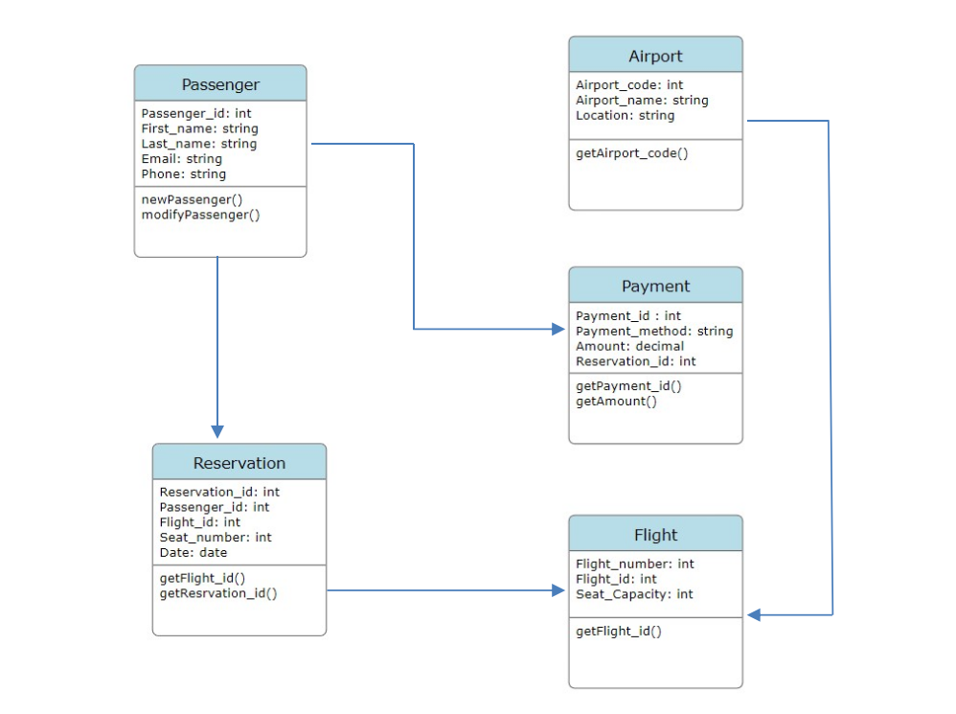

1. **Database**

